7.Design TM to perform addition .

DESIGN:

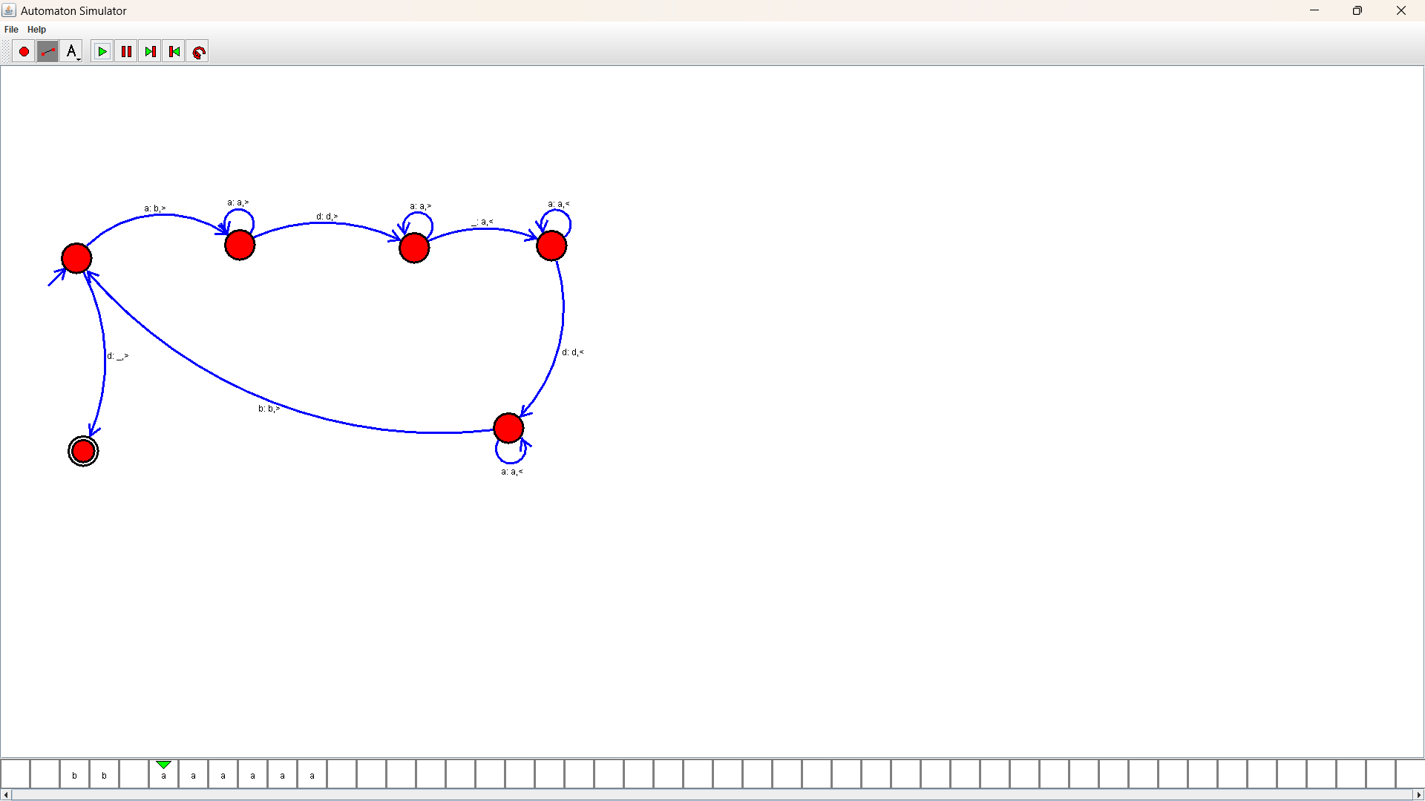

OUTPUT:

